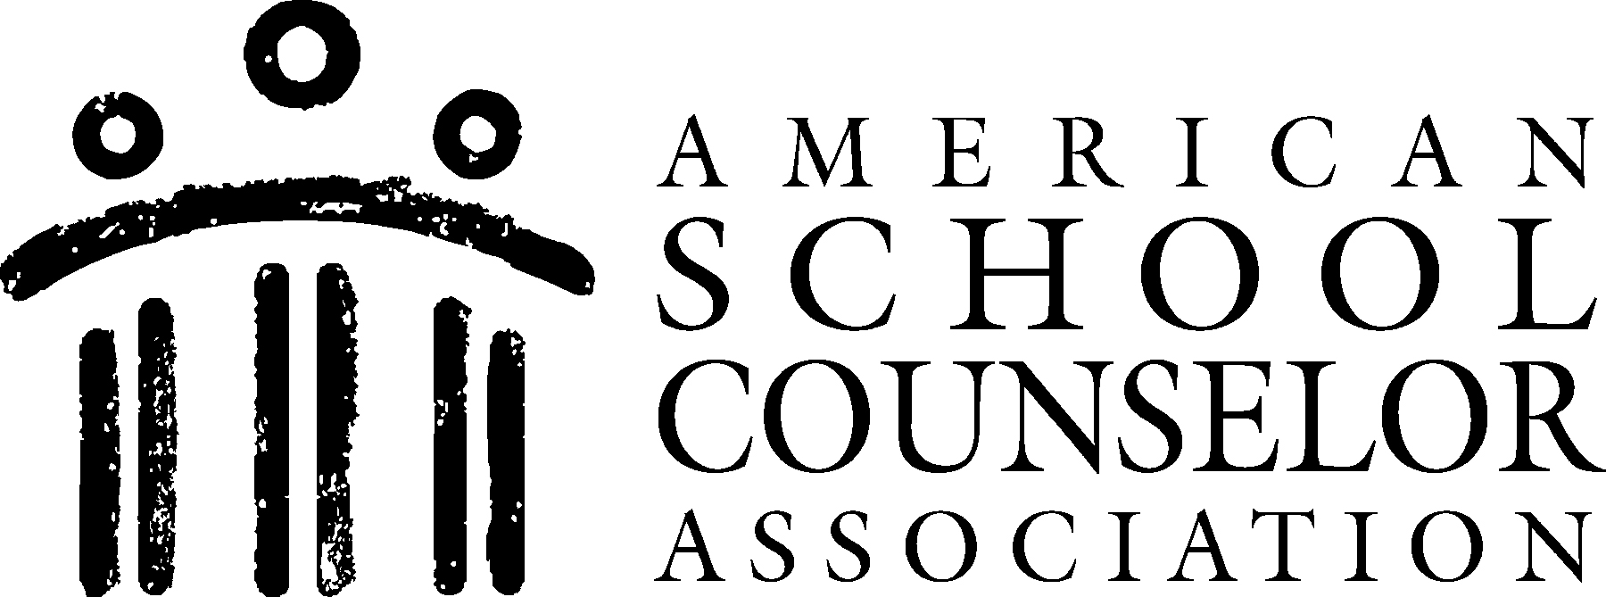 |  |  |  | SMALL GROUP ACTION PLAN
School Name |  | Budlong Elementary
Group Name |  | Friendship Skills
Goal |  | To build healthy friendship/social skills and attitudes through group interaction
Target Group |  | Grade levels K – 2; Ages 5 – 7
Data to Identify Students |  |  | Assessments & recommendations from teachers
School Counselor(s) | ASCA Domain, Standard and Student Competency |  |  |  | Outline of Group Sessions to be Delivered | Resources Needed | Process Data (Projected number of students affected) | Perception Data (Type of surveys to be used) | Outcome Data (Achievement, attendance and/or behavior data to be collected) | Project Start/Project End
Liza Reed  Counseling Intern | Persona/Social Development  PS:A1 – Acquire Self-Knowledge  PS:A1.6 Distinguish between appropriate and inappropriate behavior  PS:A1.9 Demonstrate cooperative behavior in groups  PS:A1.10 Identify personal strengths and assets  PS:A2 – Acquire Interpersonal Skills  PS:A2.6 Use effective communications skills  PS:A2.7 Know that communication involves speaking, listening and  nonverbal behavior  PS:A2.8 Learn how to make and keep friends  PS:B1 – Self-Knowledge Application  PS:B1.2 Understand consequences of decisions and choices  PS:B1.3 Identify alternative solutions to a problem |  |  |  | Session 1: Group Rules & Friendly Behaviors  Session 2: Talking & Listening Skills  Session 3: Cause & Effect in Friendships  Session 4: Creating Solutions | Construction paper  Markers  Laminator (ideally)  Eyeglasses  Bunny ears (could make yourself with headband & construction paper)  Picture cards  Puzzles and other games  Feeling chart  Solutions cards | 4 – 6 members per group  12 – 18 students total in a one-month period, if 3 groups can meet per week | Pre/post-assessment completed by teachers to identify student strengths & weaknesses in friendships and groups  Pre -assessment completed by selected students to determine knowledge of friendship skills  Post-assessment completed by student group members to determine acquired knowledge & skills | 100% of group members will be able to name 3 friendly behaviors needed to get along in groups  75% of group members will be able to identify 1 listening skill  75% of group members will be able to identify 2 ways their behaviors could affect their friends  75% of group members will be able to name 2 solutions to conflicts  Teacher assessment will show a 50% improvement in friendly behaviors among group participants | 10/14/2013 – 11/8/2013

