 | 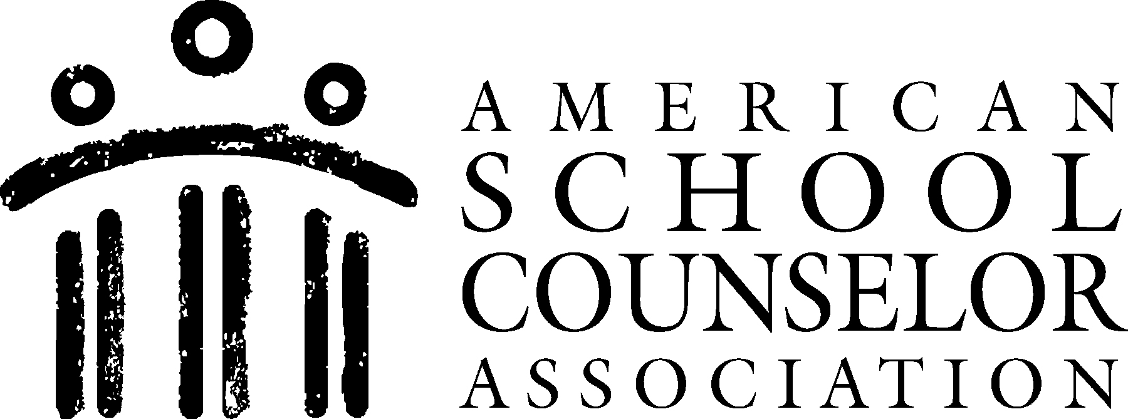 |  |  |  |  | SCHOOL COUNSELING CORE CURRICULUM ACTION PLAN
Goal |  | Students will learn to identify and utilize positive interpersonal skills to create and maintain healthy relationships with peers and adults
Lessons and Activities Related to Goal:
Grade Level |  | Lesson Topic | Lesson Will Be Presented In Which Class/ Subject |  | ASCA Domain, Standard and Competency |  | Curriculum and Materials | Projected Start/End | Process Data (Projected number of students affected) | Perception Data (Type of surveys/ assessments to be used) | Outcome Data (Achievement, attendance and/or behavior data to be collected) | Contact Person
1st and 2nd |  | Personal/Social | TBD |  | ASCA Standards:  PS: A1.4  PS: A1.5  PS: A1.6  PS: A1.11 PS: A2.2  PS: A2.3  PS: A2.6  PS: A2.8 |  | Curriculum:  Relationship Recipe  Materials:  Pre-test and post-test, plain piece of white 8 ½ X 5 ½ paper or similar size index card for each student, Markers, crayons, color pencils, scissors, glue, construction paper, etc, and paper and pencil. | 2/13/2014 – 2/14/2014 | Approximately 170 first and second grade students participated in a lesson about making and maintaining healthy relationships with friends and adults. | Students will have a better understanding of how to identify and utilize positive interpersonal skills to create and maintain healthy relationships with peers and adults. An interpersonal skills pre test will be administered prior to the lesson and an interpersonal skills post test will be given to the students directly after the completion of the lesson. | Disciplinary infractions related to unhealthy relationships have decreased 20% three months after this activity was implemented in their classrooms.  90% of first and second graders can name three interpersonal skills that will help them build healthy relationships. | Liza Reed

 |  |  |  |  |  |  | SCHOOL COUNSELING CORE CURRICULUM ACTION PLAN
Goal |  | Students will develop an understanding of various careers and develop personal interest in possible future careers.
Lessons and Activities Related to Goal:
Grade Level |  | Lesson Topic | Lesson Will Be Presented In Which Class/ Subject | ASCA Domain, Standard and Competency |  | Curriculum and Materials |  | Projected Start/End | Process Data (Projected number of students affected) | Perception Data (Type of surveys/ assessments to be used) | Outcome Data (Achievement, attendance and/or behavior data to be collected) | Contact Person
2nd, 3rd, and 4th |  | Career | TBD | ASCA Standards:  C:A1. 2  C:A1. 3  C:A1. 9  C:A2. 7  C:B2. 1 |  | Curriculum:  My Career Sundae  Materials:  The following materials are necessary for each student:  (1) Career sundae cut-out sheet packet that includes: 1 dish, 3 ice cream scoops, 3 hot fudge/caramel pieces, 3 strawberries, 3 bananas and 1 whip cream cut outs.  (1) Career cluster information review sheet that includes 1-3 examples of careers within each cluster  (1) Pencil  (1) Pack of coloring pencils  (1) Pair of small scissors  (1) Scotch Tape  (1) Yellow construction paper sheet |  | 3/13/2014 – 3/14/2014  (2 class periods needed) | This lesson plan will be conducted by a school counselor with the assistance of each class’s teacher in the 2nd, 3rd, and 4th grade classes for approximately 266 students, over two (2) 40-minute classes during regular school hours. | A verbal questionnaire will be given to students at the conclusion of the second day lesson. | 70% of students will know 3 or more careers. 100% of students will pick at least one career option that they are interested in. 70% of students will pick at least 2 career options that they are interested in. 70% of students will know 3 responsibilities of the job they are interested in, 3 skills needed to do well in the job, 3 tools needed to do the job and the educational level that must be obtained. | Liza Reed

 |  |  |  |  |  |  | SCHOOL COUNSELING CORE CURRICULUM ACTION PLAN
Goal |  | Students will become familiar with the definition and importance of academic skills and understand how utilizing these skills relates to academic achievement.
Lessons and Activities Related to Goal:
Grade Level |  | Lesson Topic | Lesson Will Be Presented In Which Class/ Subject | ASCA Domain, Standard and Competency |  | Curriculum and Materials |  | Projected Start/End | Process Data (Projected number of students affected) | Perception Data (Type of surveys/ assessments to be used) | Outcome Data (Achievement, attendance and/or behavior data to be collected) | Contact Person
4th, 5th & 6th |  | Academic | TBD | ASCA Standards:  A: A1.2  A: A1.3  A: A1.4  A: A1.5  A: A2.2  A: A2.3  A: A3.1  A: A3.2  A: A3.4  A: A3.5  A: B1.1  A: B2.1 |  | Curriculum:  My Academic Skills Balloons  Materials:  (1) 5 X 7 Printed paper photograph of him or her (needed for 2nd class)  (1) Small pair of scissors (needed for 2nd class)  (3) Pieces of heavy duty scotch tape (needed for 2nd class and follow-up)  (3) 2- inch pieces of yarn (needed for 2nd class)  (1) Small clip (needed for 2nd class)  (1) Pencil (needed for 2nd class)  (1) Small pack of Post-It notes (needed for 2nd class and follow-up)  (1) Large envelope (needed for 2nd class and follow-up)  (1) Academic skills handout sheet (needed for 1st, 2nd class and follow-up)  The following materials will be needed for the advanced prep:  Yellow piece of construction paper, large enough to trace a balloon onto (also follow-up)  Orange piece of construction paper, large enough to trace a balloon onto (also follow-up)  Light Green sheets of construction paper, large enough to trace a balloon onto (also follow-up)  (1) Computer with camera chip insert area  (1) Computer printer with color cartridges  (1) Digital camera  (1) Balloon tracing sheet (also follow-up) |  | 9/24/2014 – 9/26/2014  (2 class periods needed) | This lesson plan will be conducted by a school counselor with the assistance of each class’s teacher in all 4th, 5th and 6th grade classes or approximately 219 students. It will be conducted over two (2) 40-minute classes during regular school hours. | A short, “Academic Skills Pre-Test” will be administered to the students prior to the lesson and a short, “Academic Skills Post-Test” will be administered to students at the end of the school year. Additionally, three to six (3-6) questions will be verbally stated to students during both classes and their responses will be documented for additional data. | 70% of students or approximately 105 students will be able to define what academic skills are. 70% of students or approximately 105 students will be able to provide at least 2 reasons why academic skills are important. 70% of students or approximately 105 students will be able to list 5 examples of academic skills that are necessary to succeed in school. | Liza Reed

