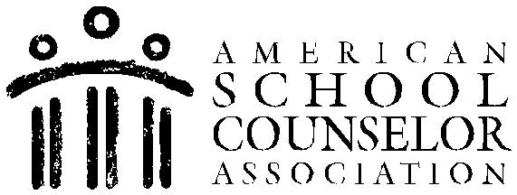

“My Academic Skills Balloons” Lesson Plan

School Counselor: Elizabeth (Liza) Reed & Current Counseling Intern

Date: TBD (September & 2 Class Periods Needed) Activity: “My Academic Skills Balloons” Grade(s): 4th, 5th & 6th
ASCA Student Standards (Domain/Standard/Competencies):

A: A1.2 Display a positive interest in learning

A: A1.3 Take pride in work and achievement

A: A1.4 Accept mistakes as essential to the learning process

A: A1.5 Identify attitudes and behaviors that lead to successful learning

A: A2.2 Demonstrate how effort and persistence positively affect learning

A: A2.3 Use communication skills to know when and how to ask for help when needed

A: A3.1 Take responsibility for their actions

A: A3.2 Demonstrate the ability to work independently, as well as the ability to work cooperatively with other students
A: A3.4 Demonstrate dependability, productivity and initiative

A: A3.5 Share knowledge

A: B1.1 Demonstrate the motivation to achieve individual potential

A: B2.1 Establish challenging academic goals in elementary, middle/junior high and high school
Learning Objective(s):

1. All students will become familiar with the definition and importance of academic skills.
2. All students will become familiar with a minimum of 5 academic skills that are necessary to succeed in school.
3. Each student will be able to identify 3 academic skills that they are good at and 3 academic skills that they would like to improve on for the quarter/term/semester/year.
4. All students will become familiar with the connection between classroom performance, success in school and success in their post-secondary life.
Materials:

The following materials are necessary for each student:

(1) 5 X 7 Printed paper photograph of him or her (needed for 2nd class) (1) Small pair of scissors (needed for 2nd class)
Heavy duty scotch tape (needed for 2nd class and follow-up) (3) 3-inch pieces of yarn (needed for 2nd class)
(1) Small clip (needed for 2nd class) (1) Pencil (needed for 2nd class)
(1) Small pack of Post-It notes (needed for 2nd class and follow-up) (1) Large envelope (needed for 2nd class and follow-up)
(1) Academic skills handout sheet (needed for 1st, 2nd class and follow-up) The following materials will be needed for the advanced prep:
Yellow piece of construction paper, large enough to trace a balloon onto (also follow-up) Orange piece of construction paper, large enough to trace a balloon onto (also follow-up) Light Green sheets of construction paper, large enough to trace a balloon onto (also follow-up)
(1) Computer with camera chip insert area (1) Computer printer with color cartridges (1) Digital camera
(1) Balloon tracing sheet (also follow-up)

Lesson 1 Procedure:

1) Prompt students to take their seats and listen. Explain to students that, “Before we begin our lesson, you are all going to take a very short test. This test is only to gather information and will not count at all for a grade. After you all take this test, we will discuss the questions on the test between today’s lesson and the next lesson. Please read the directions carefully and do your best. You will have 5 minutes to complete the test. If you do not know how to answer a question, simply write, “I don’t know” below the question that is being asked. You are not allowed to ask me or your peers for help. You must take this test by yourself. Again, this will not be graded.”
2) Explain to students, “No more talking, I am now going to hand out the test. When you are finished taking the test, please flip it over and put your head down so I know you’re finished. Please sit quietly until all tests have been collected.” Hand out the Academic Skills Pre-Test.
3) Allow students 5-7 minutes to take the test.

4) Collect all tests.

5) Ask students, “By raising your hand, who thought this test was kind-of hard?” Check to see how many hands went up and write it down. Then ask, “By raising your hand, who thought this test was kind-of easy?” Check to see how many hands went up and write it down.
6) Now begin the lesson by stating, “Most of your parents or caretakers have a job. To keep their job they must be good workers. To show they are good workers they must use specific skills on a regular basis. If they don’t do their job well and are not good workers, please raise your hand and tell me what you think will happen to them.”
7) Allow students to answer. Reinforce or supplement their statements with, “They could get in trouble; lose their job/get fired.” Explain to students that, “When a person loses their job many unfortunate things may happen like they may not have enough money to buy food, they may lose their house; they may lose their car etc.”
8) Continue by asking students, “Now, what happens if they do their job well by working hard and using good job skills?” Allow students to answer and reinforce/supplement their responses by saying things like, “They get a promotion which means they get a “higher position”, they may be given more money, they may get a nicer office, they may be given a car and they may be allowed to make more decisions on their own without having to check with their boss because their boss trusts them more.”
9) Continue to explain to the students, “Your job, believe it or not, is to be a good student until you’re old enough to get a job. Now, what happens if you’re not a good student?” Allow students to answer. Reinforce/supplement their responses by sharing such things as, “You may get a detention, you may not get as good of a grade as you could get, your parents may be disappointed with you and may even ground you and you may not learn
as much as you could learn.”
10) Continue by sharing, “Since each one of your jobs is to be a good student can anyone tell me, by raising their hand, what skills are necessary to be a good student?”
11) As students give their answers, write each academic skill on the board. Reinterpret them if necessary. After you’ve written about 8-10 responses, explain to the students that these are examples of academic skills. Write, “Academic Skills” above the examples on the board and this definition beside it: skills needed to do well in an educational setting. Be sure the students understand what educational setting means by clarifying the term.
12) Begin exploring each academic skill individually with the students by asking them to give reasons as to why they think that skill is an important skill to practice/learn and have for school and then explore why it would be an important skill to have for a career/job. When necessary, elaborate on their responses.
12) Next, pass out the “Academic Skills Information Sheet” and have the students take turns reading each one of the skills out loud.
13) Conclude the lesson by stating, “Now that you know what academic skills are and you have many examples of them, for the next class your homework will be to think about and pick 3 skills that you think you are good at and 3 skills that you think you might need to improve on from this list. For the 3 skills you are good at put a star near them. For the skills you think you need to work on go ahead and circle the whole skill. (Write these directions on the board.) Additionally, please show your parents/caretakers the list of academic skills and ask them which one/how many of these or similar skills they use in their job and have them place a check mark next to those skills that they use in their job. Then have them sign their full name and fill in the date at the bottom of the
page to show me that they did review them with you. If your parents are up for it, you can also ask them in what ways they use these skills in their careers/jobs. If you would also like a copy of these skills in Spanish, please raise your hand and I will provide you with one.”
14) Conclude the class by sharing that, “Next class we will review the homework and then we will be doing a fun activity with the academic skills that you chose. Also
between now and our next class please know that I will be taking a picture of you at some point for the activity.” Be sure to tell the students what day their homework will be due on.
Lesson 2 Procedure:

(Prior to the student’s arrival you must do the following):

1) Take a 5X7 picture of each student and print it out. Consider taking the pictures during recess so as to avoid taking teacher’s instructional time.
2) Have the definition of academic skills as well as 6-8 examples of academic skills on one side of the board prior to the student’s arrival and your academic skills balloons taped onto the board on the other side of the listed skills.
3) Have all of the materials that the students will need to complete the project on each of their desks.
Lesson 2 Procedure Continued:

4) Prompt the students to review what they did and what was discussed last class. Be sure to include that it is their job to be a good student, just as it is their parent’s /caretaker’s job to be a good worker and learning good academic skills now, will help them have good skills in the future.
5) Explain to students that, “While you are in school you should be practicing, learning and using many skills that will help you be the best student that you can be. By a show of hands, how many of you didn’t even realize that you had already been actively using many of these academic skills in school? (Write down the number.) Now, remember that you will not only need these skills while you are a student but you will also need most of these skills or similar skills one day when you get a job because these skills will help you be the best worker you can be. In fact, by a show of hands, how many of your parents/caretakers use 5 of the skills on the paper? How many used 10? How many used
15 or more?” (Write down the number.)

6) Explain to the students, “Since learning and using good academic skills is important now while you’re a student and later when you are a worker or employee at a job, you too are going to actively start focusing on using your academic skills just like your parents/caretakers actively focus on and use their skills at work.”
7) Share with your students that, “Today you are all going to make your own Academic Skills Balloons. To make your Academic Skills Balloons you will need the 3 academic skills that you circled or wrote down that you would like to practice more either because
they are new to you or because you think you can be even better at using them because as you know, practicing them will help you improve them.”
8) Show students your academic skills balloon example and explain that because you are not a student, they are actually your job skills balloons, which is equivalent to their academic skills balloons since their job is to be a student and yours is to be a school counselor. Continue by explaining your skills, why you chose them and communicate that as an adult it’s also important to ensure you are using your skills as best you can. Lastly, explain that both adults as workers and children as students need to review these skills and sometimes change them if they think they need to work on other skills more.
Express to the students that it’s therefore, good practice to think about what skills you are good at and which ones you need to practice more throughout their years as a student as well as when they become a working adult.
9) Review with the students everything they have on their desk and what they will need it for to complete their Academic Skills Balloons. Have students start the project and share with them that you and the teacher are available for help or questions.
10) As the students are working on their Academic Skills Balloons share with them that they will be hung in their classroom and that they will review them at the end of each term/quarter/semester during homeroom. When it’s time to review them, they can either choose to keep working on them for the next term/quarter/semester/year or they can change all 3 by adding 3 more so that the new balloons reflect what they would like to keep working on/practicing.
11) Towards the end of the class period, be sure to instruct your students on how they should clean up and where they should place their balloons for you/the teacher to put up.
12) Leave 5 minutes for students to take the post-test. After it has been taken, ask students to respond to the following questions by raising their hand, “By raising your hand, how many of you thought this test was hard?” Then ask, “How many of you thought this test was easy?”
Evaluation:

Process Data: This lesson plan will be conducted by a school counselor with the assistance of each class’s teacher in all 4th, 5th and 6th grade classes or approximately 219 students. It will be conducted over two (2) 40-minute classes during regular school hours.
Perception Data: A short, “Academic Skills Pre-Test” will be administered to the students prior to the lesson and a short, “Academic Skills Post-Test” will be administered to students at the end of the school year. Additionally, three to six (3-6) questions will be verbally stated to students during both classes and their responses will be documented for additional data.
Outcome Data: 70% of students or approximately 153 students will be able to define what academic skills are. 70% of students or approximately 153 students will be able to provide at least 2 reasons why academic skills are important. 70% of students or approximately 153 students will be able to list 5 examples of academic skills that are necessary to succeed in school.
Follow Up: Provide the homeroom teacher with extra cut-out balloons of different colors, tape, pencils, sticky notes and several Academic Skills Sheets. At the end of the quarter/term/semester students will be asked during homeroom to review their academic skills balloons and decide whether they would like to continue working on the same academic skills in the next quarter/term/semester or whether they would like to add new academic skills balloons. If they would like to add new balloons have the teacher provide them with the necessary amount of balloons and an Academic Skills Sheet that they will have to return upon completion. Have the homeroom teacher place the balloon with the child’s name shown on a sticky pad in an envelope so that you can replace and put them up at a later point.
At the beginning of the following year, homeroom teachers can request students to write down in their planners the academic skills they would like to focus on that term/quarter/semester.
ACADEMIC SKILLS PRE-TEST Name:
Date:

1. Please explain what academic skills are. If you are unsure please write, “Not sure.”

Academic Skills are

2. Do you think having good academic skills is important?

1) Yes

2) No

3) Not Sure

3. List one reason that you think having good academic skills is important. If you’re not sure, leave the space blank.

4. Please list 5 examples of academic skills. If you are unsure please write, “Not sure” next to the #6 space and leave all other numbers blank.

1)

2)

3)

4)

5)

6)

5. Can learning and practicing good academic skills in school now, be useful for your future as a college student and an employee at a job? Please circle one option.

a) Yes b) No
c) Not sure
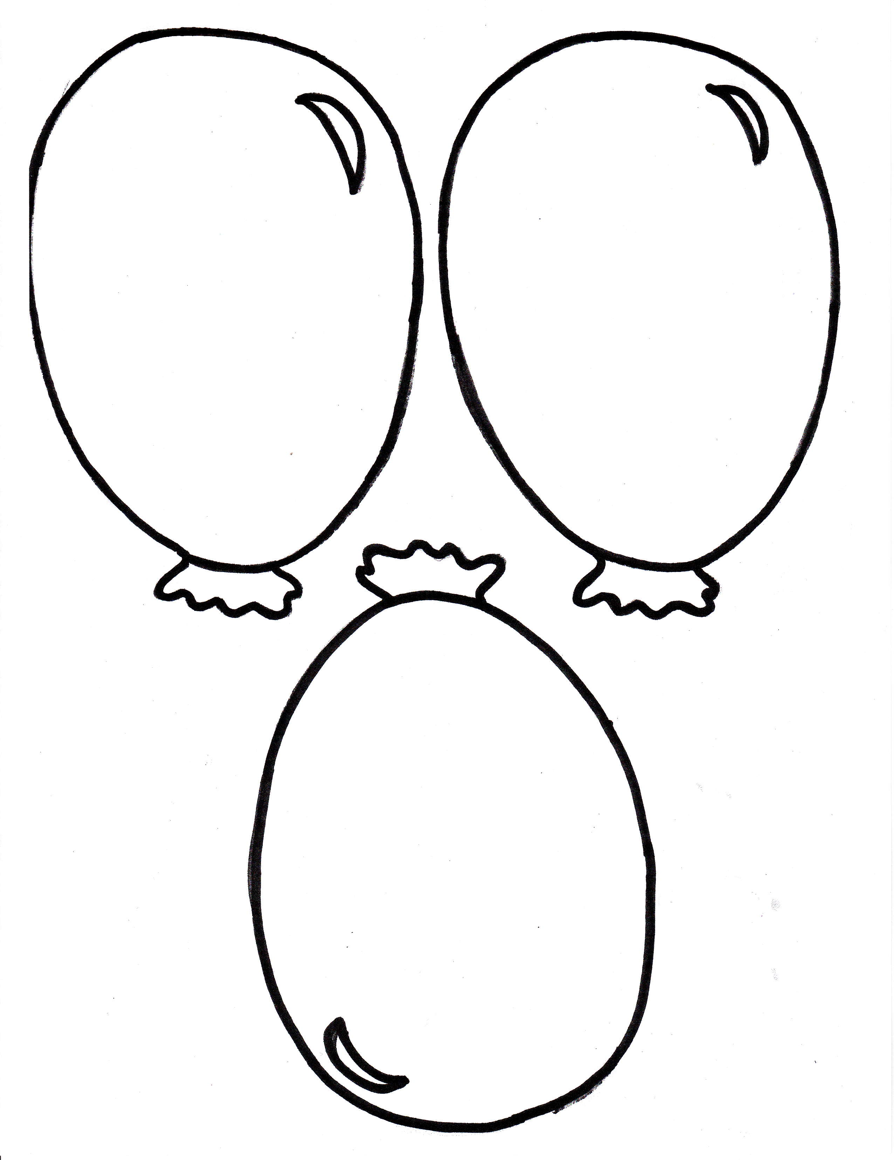

Name: Date:
ACADEMIC SKILLS POST-TEST

1. Please explain what academic skills are. If you are unsure please write, “Not sure.”

Academic Skills are

2. Do you think having good academic skills is important?

1) Yes

2) No

3) Not Sure

3. List one reason that you think having good academic skills is important. If you’re not sure, please write, “not sure”.

4. Please list 5 examples of academic skills. If you do not know 5 examples, write as many as you know. If you are unsure how to answer this question, please write, “Not sure” next to the #6 space and leave all other numbers blank.

1)

2)

3)

4)

5)

6)

5. Can learning and practicing good academic skills in school now, be useful for your future as a college student and an employee at a job? Please circle one option.

a) Yes b) No
c) Not sure

6. Do you think that the “My Academic Skills Balloons” lessons helped you understand what academic skills are?

a) Yes b) No
d) Not sure

7. Do you think that the “My Academic Skills Balloons” lessons helped you learn new or more examples of academic skills?

a) Yes b) No
c) A little bit d) Not sure
8. Do you think the “My Academic Skills Balloons” project helped you be a better student in school?

a) Yes b) No
d) Not sure

9. How do you think the, “My Academic Skills Balloons” lesson helped you? Circle as many as are true for you.

a) Helped me learn better

b) Helped me be more organized c) Helped me behave better
d) Helped me do my homework better e) Helped me study better
f) Helped me do my classwork better g) Helped me work better with others
h) Helped my parents be more proud of me i) Helped me be more proud of myself

