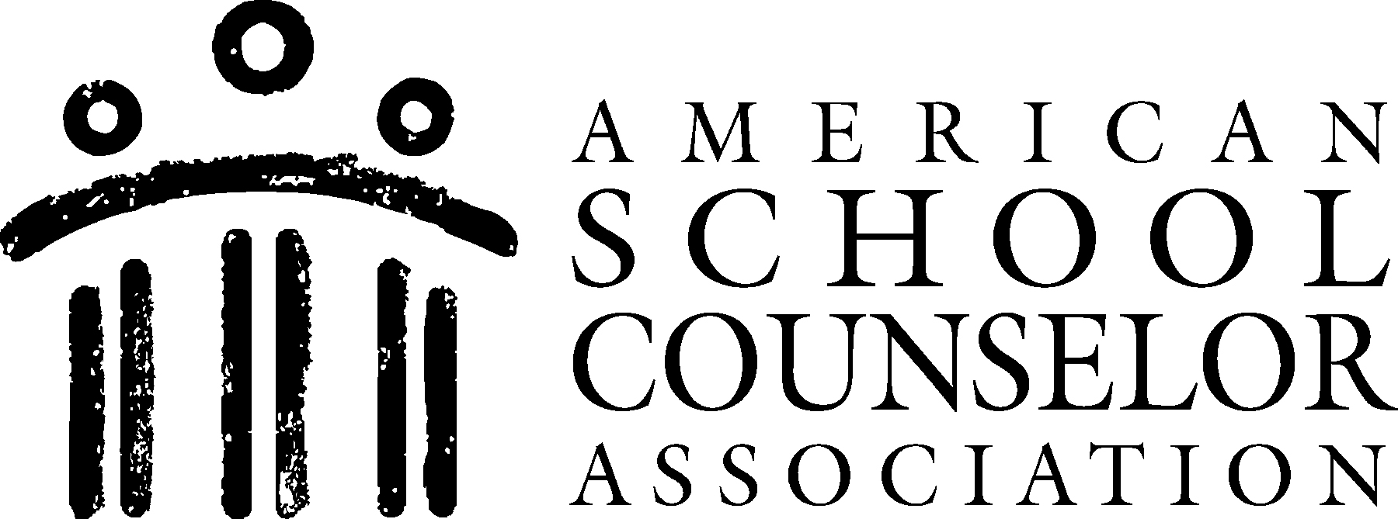 |  | CLOSING THE GAP ACTION PLAN
School Name | Budlong Elementary School |  |  |  |  | Year: | 2013-2014
Goal: | Increased knowledge of school support services, diversity, conflict resolution, and healthy relationships
Target Group: | First and second grade students
Data to Identify Students
School Counselor(s) | ASCA Domain, Standard and Student Competency | Type of Activities to be Delivered in What Manner? | Resources Needed | Process Data (Projected number of students affected) | Perception Data (Type of surveys to be used) | Outcome Data (Achievement, attendance and/or behavior data to be collected) |  | Project Start/Project End
Liza Reed | PS:A1 Acquire Self-knowledge  PS:A1.5 Identify and express feelings  PS:A2 Acquire interpersonal skills  PS:A2.3 Recognize, accept, respect and appreciate individual differences  PS:A2.4 Recognize, accept and appreciate ethnic and cultural differences  PS:A2.8 Learn how to make and keep friends  PS:B1 Self-knowledge Application  PS:B1.2 Understand consequences of decision and choices  PS:B1.3 Identify alternative solutions to a problem  PS:B1.4 Develop effective coping skills for dealing with problems  PS:B1.5 Demonstrate when, where and how to seek help for solving problems and making decisions  PS:B1.6 Know how to apply conflict resolution skills  PS:B1.8 Know when peer pressure is influencing a decision  PS:C1 Acquire Personal Safety Skills  PS:C1.5 Differentiate between situations requiring peer support and situations requiring adult professional help  PS:C1.6 Identify resource people in the school and community, and know how to seek their help  PS:C1.8 Learn about the emotional and physical dangers of substance use and abuse  PS:C1.9 Learn how to cope with peer pressure. | Peer-led classroom lessons and group work | (1) Calendar of “Buddy” workshops  (2) Hardcopy training materials for annual “Buddy” training  (3) Hardcopy recruiting materials for “Budlong Buddies” program  (4) Permission slips for “Buddies”  (5) Games/activities (as needed) for individual workshops  (5) Workshop evaluation forms for students, teachers and “Buddies” | All first and second classrooms (c. 170 students). Each classroom will have a two-person male/female “Buddy” team. The “Buddy” team will meet with their pre-assigned classroom at least once a month. | Through pre/post testing, all first and second grade students will demonstrate knowledge of at least (1) skill in each of the following areas: conflict resolution, healthy friendship cultivation, and bullying intervention. They will also identify at least (1) adult in the school environment that they can go to for support. All first and second grade students will also correctly identify the school’s counselor and at least (2) services the school counselor provides. | A 75% reduction in school infractions related to interpersonal misconduct at the 1st and 2nd grade levels. A 25-30% increase in 7th and 8th grade students’ involvement in leadership service to Budlong. |  | August 2013 to May 2014

